Test file

Hello, this is a test file.

This is a test picture:

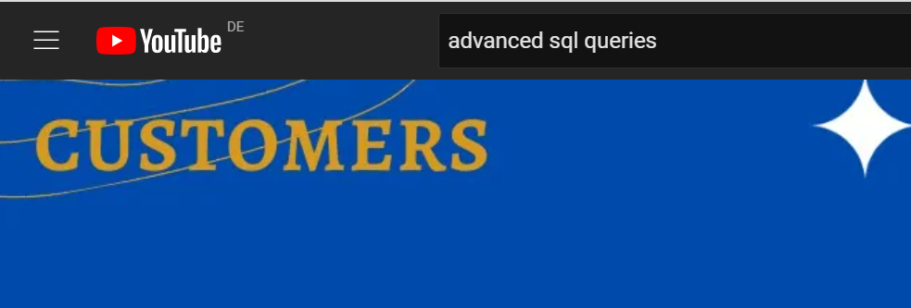

Test file ends.